**Mental Health Application Project Description**

**Audience**

* U.S. Adults suffering from mental health issues due to COVID

**Problem and need**

* The COVID-19 pandemic may have brought many changes to how people live, and with it, at times, uncertainty, altered daily routines, financial pressures, and social isolation. People may worry about getting sick, how long the pandemic will last, whether our job will be affected and what the future will bring. Information overload, rumors and misinformation can make our life feel out of control and make it unclear what to do.
* During the COVID-19 pandemic, we may experience **stress, anxiety, fear, sadness and loneliness, a**nd mental health disorders, including **anxiety and depression,** can worsen.
* Surveys show a major increase in the number of U.S. adults who report symptoms of stress, anxiety, depression, and insomnia during the pandemic, compared with surveys before the pandemic. Some people have increased their use of alcohol or drugs, thinking that can help them cope with their fears about the pandemic. Using these substances can worsen anxiety and depression.
* For all of these reasons, it's important to manage our own mental health and get care when needed.([COVID-19 and your mental health - Mayo Clinic](https://www.mayoclinic.org/diseases-conditions/coronavirus/in-depth/mental-health-covid-19/art-20482731))
* [Studies](https://www.wendysuzuki.com/) show that **aerobic exercise** can be used to improve mental health (e.g., anxiety). We want to use this concept to help improve people`s mental health due to COVID.

**Objective/ Scope of this project**

* Building a patient-facing application which can monitor a patient’s exercise and mental health level, and potentially improve mental health by exercise intervention and behavior change.
* Building a physician/caregiver-facing application which can assist the physician/caregiver to understand the patient’s situation and intervenes accordingly.

**Desired features**

* Patient-facing application
  + Record PHR
    - Vital signs (heart rate, heart rate variability, skin temperature, etc.) from Apple watch
    - Aerobic exercise data (steps, etc.) from Apple watch and smartphone apps (Apple Health App, Fitbit App, etc.). Record time and period
    - Depression questionnaire response ([PHQ-9](https://integrationacademy.ahrq.gov/sites/default/files/2020-07/PHQ-9.pdf)). Ask questionnaire once per day, at evening
  + Show PHR
    - Vital signs and exercise trend
    - Depression severity score
  + Notification
    - Send a notification to patient when vital is too low (nice to have)
  + Authentication
    - Patient can sign in the application and access to only his/her own data via OpenID Connect, which includs ID token for ID linkage, and OAuth for API linkage
* Physician/caregiver-facing application integrated into EHR system
  + Show the above patients PHR in EHR systems
  + Send a notification to physician/caregiver when depression level of the patient reaches the pre-setting threshold (nice to have)
  + Intervene (Care Plan, etc.) via application when PHQ-9 score is too low (nice to have)
  + Authentication
    - Physician/caregiver can sign in the application using EHR system account ID
    - Physician/caregiver is allowed to see approved/relevant patient data

**UX/UI Design**

Patient app demo link: <https://xd.adobe.com/view/dc8085b7-2807-40a1-aace-bb4644eae069-89d3/>

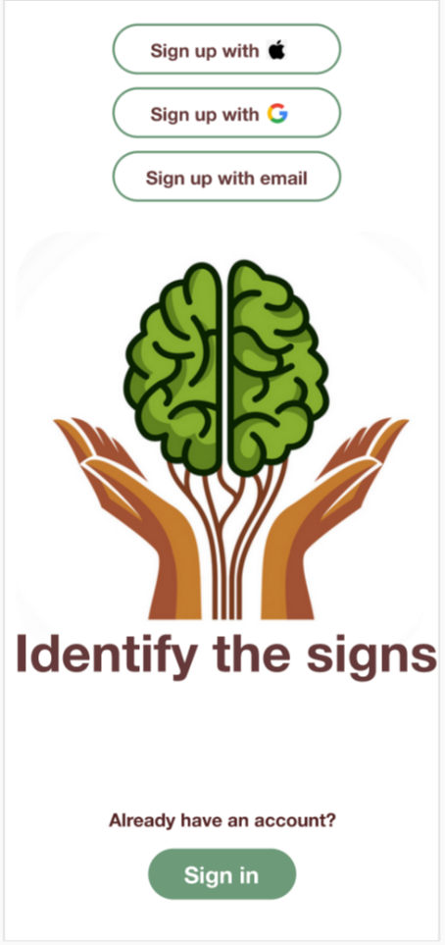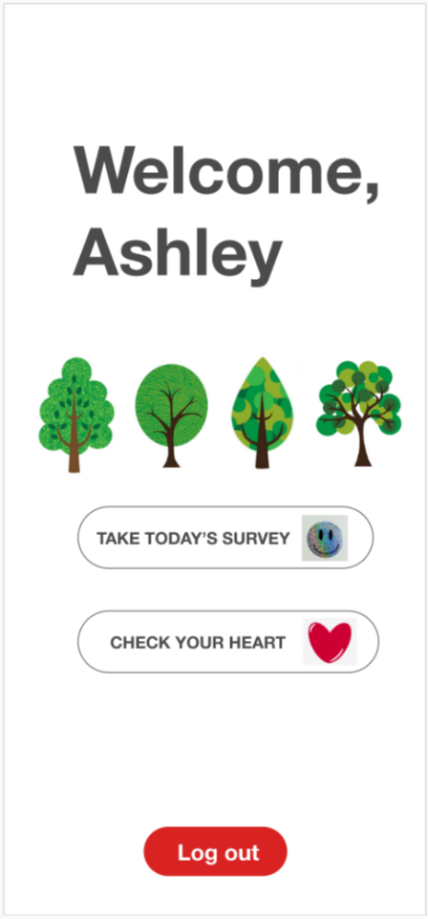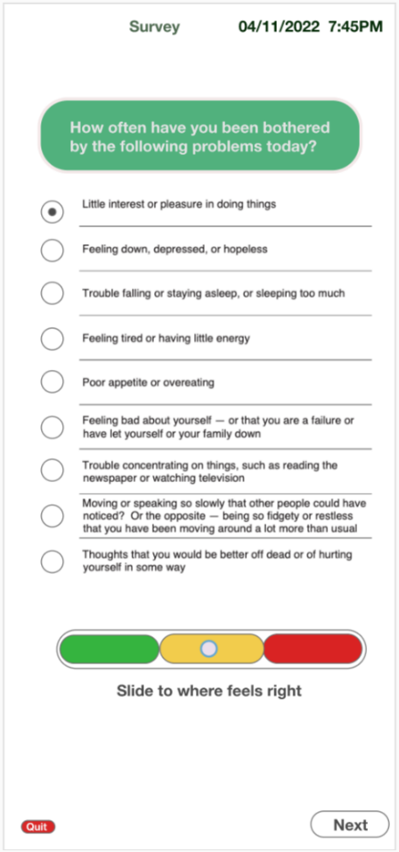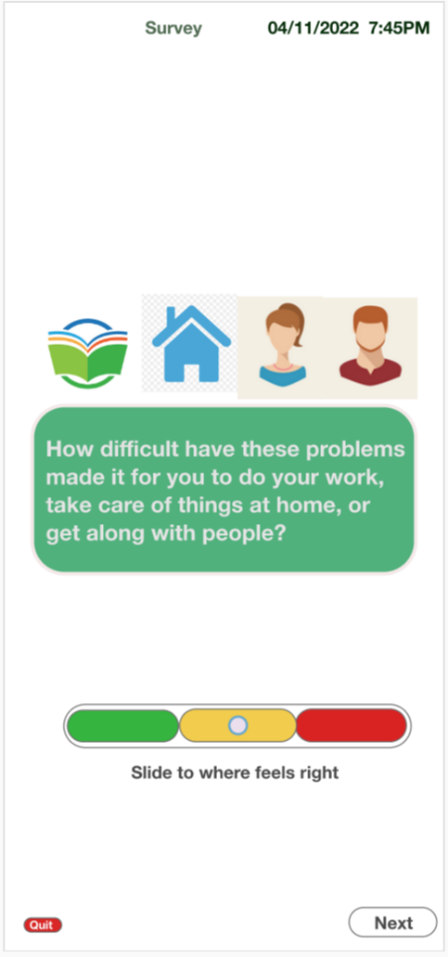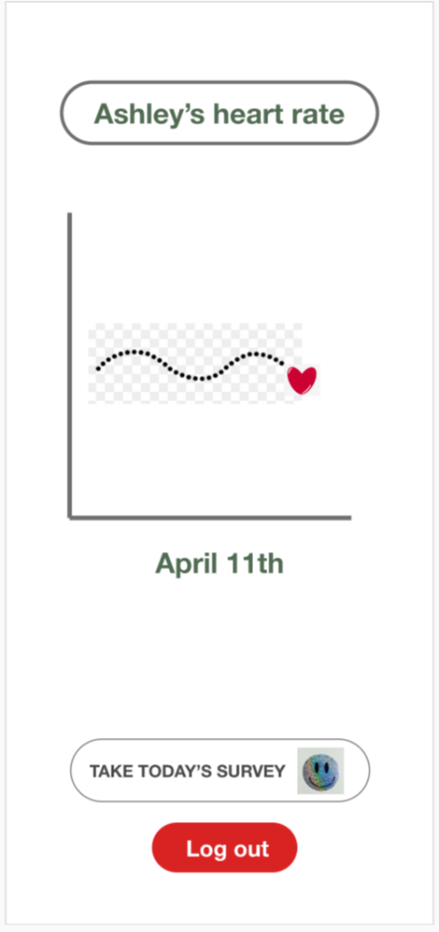

**Relevant data in FHIR** (**See diagrams and figures below for visual context)

|  |  |  |  |
| --- | --- | --- | --- |
| Data Element | HL7 FHIR Resource | Description | Bindings |
| Patient demographic | Patient | Person who plays the patient role (e.g., age, address, gender) | Patient.id  Patient.active  Patient.name[0].use  Patient.name[0].family  Patient.name[0].given[0]  Patient.gender  Patient.birthDate  Patient.address.country  Patient.address.postalCode  Patient.address.state  Patient.address.city  Patient.address.line |
| Physician | Practitioner | Person who plays the role of physician, caregiver, etc. | Practitioner.id  Practitioner.name[0].family  Practitioner.name[0].given  Practitioner.gender  Practitioner.birthDate  Practitioner.address.country  Practitioner.address.postalCode  Practitioner.address.state  Practitioner.address.city  Practitioner.address.line |
| Care team | CareTeam | Group of practitioners responsible for patient monitoring | CareTeam.id  CareTeam.category.text  CareTeam.name  CareTeam.subject  CareTeam.member  CareTeam.reasonCode.text  CareTeam.status |
| Patient symptom | Condition | Persistent patient symptoms that need long term management | Condition id  Condition code |
| Vital sign | Observation | Vital signs such as blood pressure temperature, height, weight | Observation.id  Observation.patient  Observation.value-quantity  Observation.date  Observation.device |
| Exercise | Procedure | A procedure done by patient as a part of treatment plan | Procedure.id  Procedure.patient  Procedure.date  Procedure.category  Procedure.based-on  Procedure.status |
| PHQ-9 | Questionnaire | A structured set of questions | Questionnaire.id  Questionnaire.subject-type  Questionnaire.code  Questionnaire.jurisdiction  Questionnaire.description  Questionnaire.title  Questionnaire.url |
| PHQ-9 Responses | QuestionnaireResponse | A structured set of questions and their answers. | QuestionnaireResponse.id  QuestionnaireResponse.questionnaire  QuestionnaireResponse.part-of  QuestionnaireResponse.based-on  QuestionnaireResponse.status |



**API Code Example**

**Code in its entity can be found: <https://jsfiddle.net/timekamister/ofhcverz/221/>

**Patient Demographics
**

Figure Patient Demographics

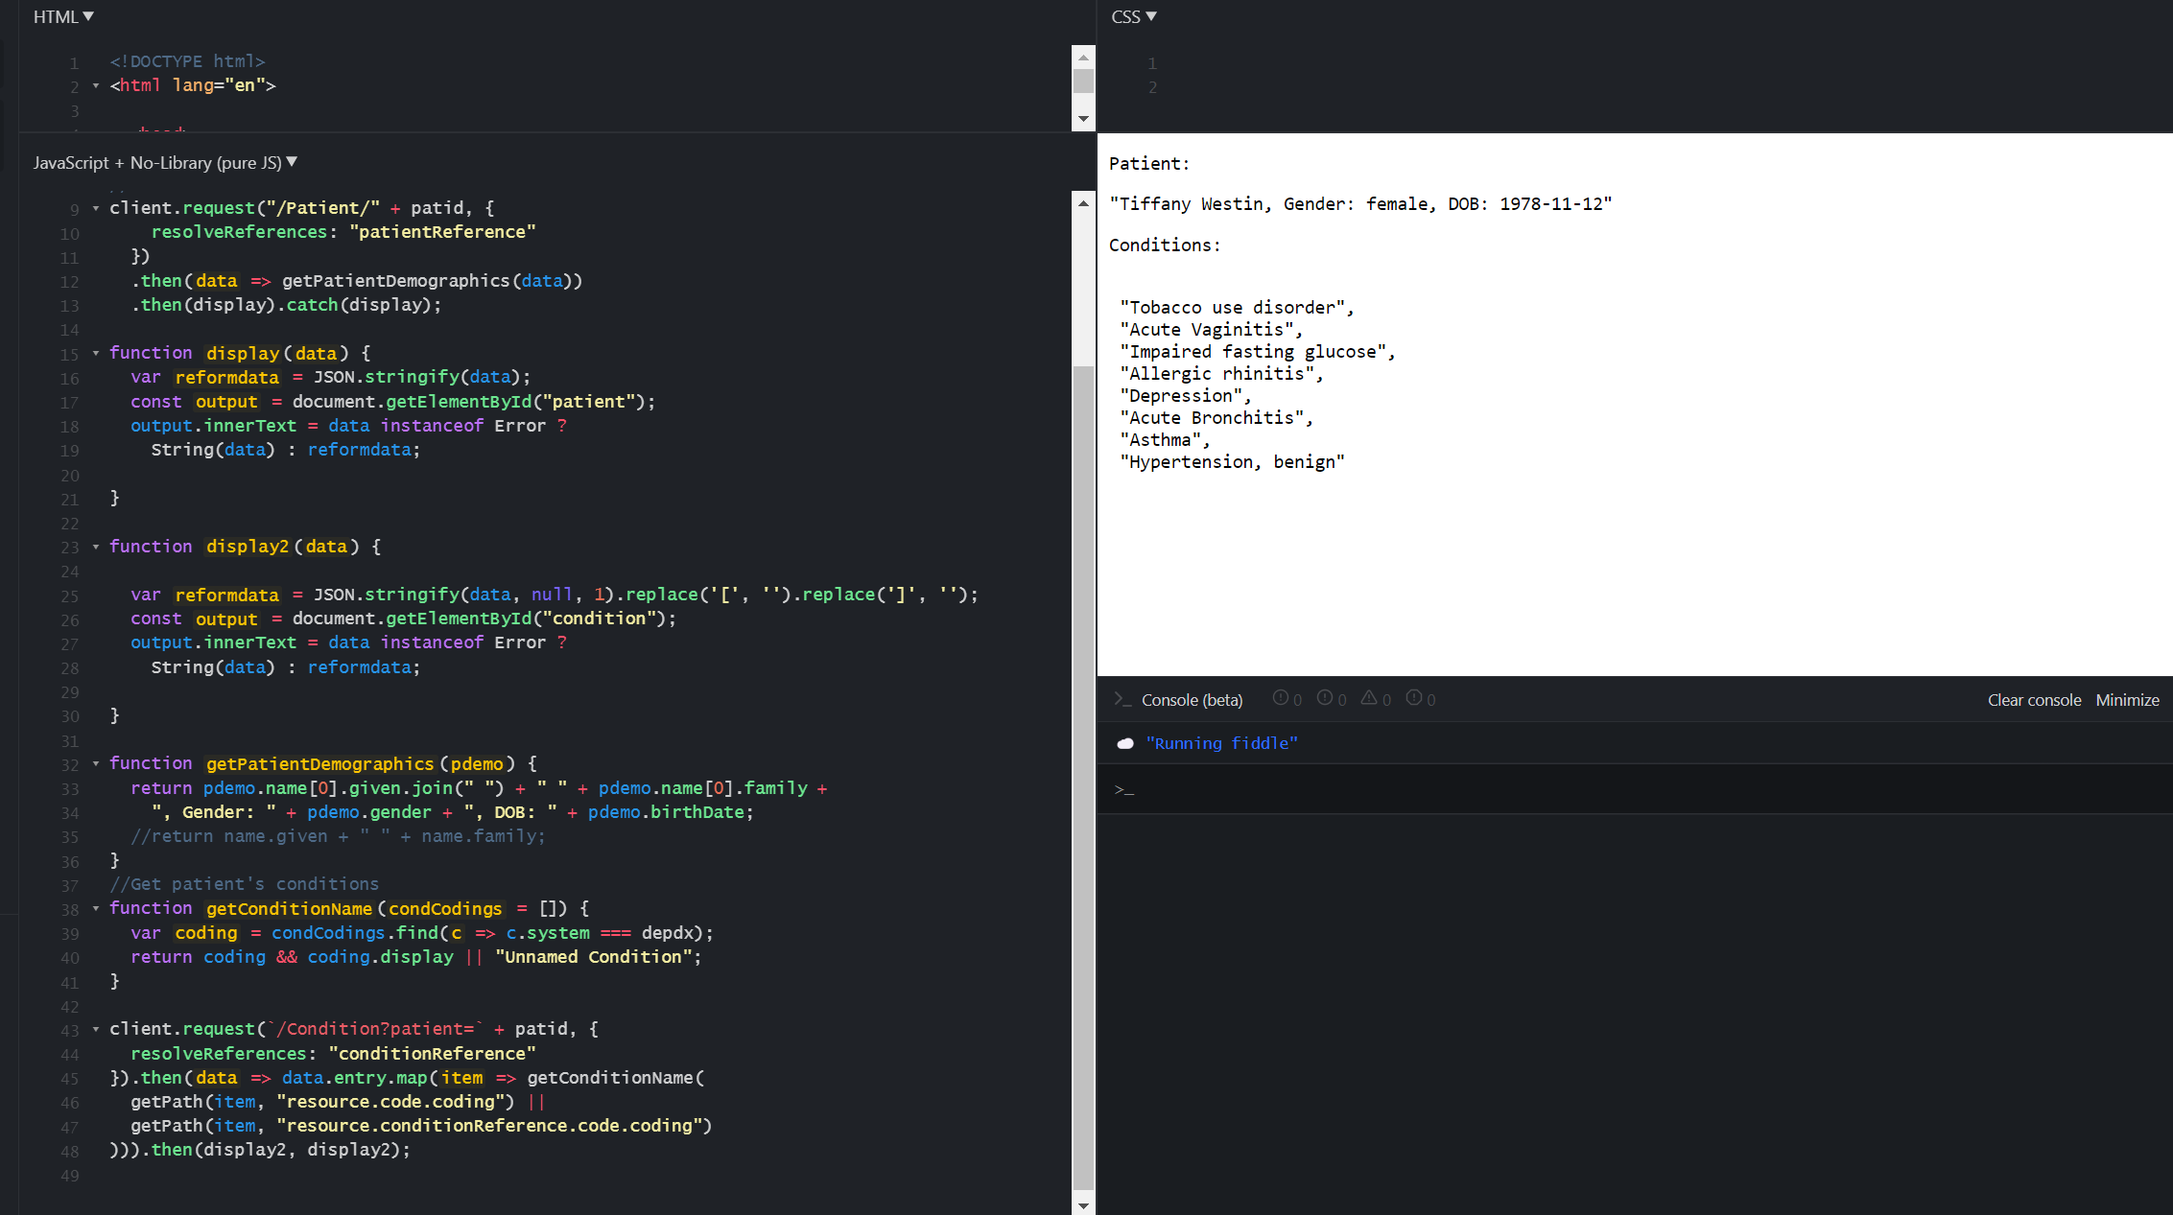

Figure 2 Patient Demographics and Conditions

Figure 3 Patient's Additional Information

**Will it be embedded or freestanding?**

Freestanding

**Meaning of embedded and freestanding

* Embedded: inside an EHR, use EHR login, usually on a website, access to all the EHR data
* Freestanding: outside an EHR, token login, not running in EHR system but on a separate server

**Will it store custom data? Where?**

No custom data storage. Just API connection, including pushing vital signs, exercise data and mental health questionnaire data from patient devices to hospital EHR server and FHIR server, and pulling those data from EHR server and FHIR server to EHR client and patient client.



*Figure High-level architecture figure showing APIs, authentication, where data is stored*

**Relevant challenges and potential solutions**

|  |  |  |
| --- | --- | --- |
| **Category** | **Challenges** | **Solutions** |
| Complicated authentication and authorization | Authentication and interoperability are important and have issues in the wild. For example, Duke`s SMART on FHIR has complicated private key authentication between different severs, limiting interoperability and leading to privacy/security trust issue. | * A common gateway (a third-party privacy and security guaranty) provided by tech giant, such as Google, may be a potential solution. However, another challenge is convincing providers to adopt this solution. * Other efforts include the Clinical Information Modeling Initiative (CIMI), whose stated mission is to “Improve the interoperability of healthcare systems through shared implementable clinical information models.” Initiatives such as CIMI exist because the use of FHIR does not guarantee interoperability, and much work will still be required to ensure that data elements mapped in different EHRs relay the same clinical content when used with FHIR. |
| Patient identity matching with duplicates and errors | Patient matching (also called identity matching) is the process of linking a patient’s data across different healthcare systems to create a holistic health record. One of the prerequisites of interoperability, if done poorly, can lead to catastrophic events, from million-dollar HIPAA violations to fatal medical errors.  There is currently no official tooling to quickly locate duplicates and errors and then combine them in a single record, so most of the patient matching is done manually or not done at all. A quick implementation timeline and lack of clear guidelines for patient matching may result in creating even lower quality data after FHIR is implemented. | * A Master Patient Index (MPI) may be a potential solution. It is a database aggregating patient data from different systems and uses algorithms to find relations between data elements. MPIs are usually sold by EHR providers. * HL7.org is also seeking input from the implementer community on what effect linking/merging/unlinking should have on functionality such as the GET operation, searching, reverse includes, etc. This functionality and related behaviors are subject to ongoing experimentation and implementation testing, with a definition to be proposed in a future version of FHIR specification. |
| Complicated FHIR extensions and profiles | FHIR resources are designed with the 80/20 rule in mind – focus on the 20% of requirements that satisfy 80% of the interoperability needs. To this end, resources are designed to meet the general or common data requirements of many use cases to avoid the proliferation of numerous, overlapping and redundant resources." Hence, FHIR resources need to be extended when dealing with specialty health data, such as IoT data, which falls outside of the most used clinical data. | * Efforts of simplifying FHIR extensions. (Example: [Aidbox](https://www.health-samurai.io/aidbox)) * Continuous FHIR data format revision to meet new interoperability needs. (Example: [Enable continuous ECG storage and monitoring](https://link.springer.com/article/10.1007/s40860-021-00161-2)) |

**What language(s) / development environment(s) will it use?**

* XCode (Integrated Development Environment)
* Swift
* JavaScript
* HTML
* CSS
* Python

**Development Plan**



**References**

1. [SMART on FHIR White Paper for HIMSS 15 (06Apr2015) (smarthealthit.org)](http://smarthealthit.org/wp-content/uploads/SMART-on-FHIR-White-Paper-for-HIMSS-15-06Apr2015.pdf)
2. [Resourcelist - FHIR v4.0.1 (hl7.org)](https://www.hl7.org/fhir/resourcelist.html)
3. [Overview-arch - FHIR v4.0.1 (hl7.org)](https://www.hl7.org/fhir/overview-arch.html#principles)
4. Merging Records, [Patient - FHIR v4.0.1 (hl7.org)](https://www.hl7.org/fhir/patient.html)
5. [example-code-page (philips.com)](https://www.philips.com/a-w/en_connectedlife-hackathon/api/example-code-page.html)
6. [Step count – Open mHealth](https://www.openmhealth.org/schemas/omh_step-count/)
7. [Pushpull - FHIR v1.0.2 (hl7.org)](https://www.hl7.org/fhir/DSTU2/pushpull.html)
8. [HL7.FHIR.US.SANER\Actors and Transactions - FHIR v4.0.1 (audaciousinquiry.github.io)](https://audaciousinquiry.github.io/fhir-saner/actors_and_transactions.html)
9. [Mobile Devices and Health | NEJM](https://www.nejm.org/doi/full/10.1056/NEJMra1806949)
10. Richard A. Bloomfield J, Felipe Polo-Woodb, Joshua C. Mandel c, Kenneth D. Mandl. Opening the Duke electronic health record to apps: Implementing SMART on FHIR, Int J Med Inform. 2017 Mar;99:1-10. [DOI: 10.1016/j.ijmedinf.2016.12.005](https://link.springer.com/article/10.1007/s40860-021-00161-2)
11. [Open mHealth, FHIR and beyond](https://www.slideshare.net/SFHIR/open-mhealth-fhir-and-beyond)
12. [A mobile health monitoring-and-treatment system based on integration of the SSN sensor ontology and the HL7 FHIR standard](https://www.researchgate.net/publication/333014867_A_mobile_health_monitoring-and-treatment_system_based_on_integration_of_the_SSN_sensor_ontology_and_the_HL7_FHIR_standard)
13. [Top 3 FHIR Adoption Challenges In 2021: How To Fix Them?](https://www.capminds.com/blog/top-3-fhir-adoption-challenges-in-2021-how-to-fix-them/)